1. **What is docker file?**

**Docker files means building an image through script. Script written in docker file. Further you can create container from that image.**

**Now deep dive into commands:**

1. **Creating first dockerfile.**



**#docker image build -t testnginx .**

**Above command will generate image by using Dockerfile script**

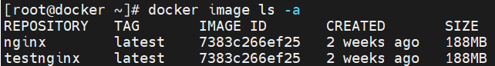

1. **Adding run command for pre-installation of packages.**

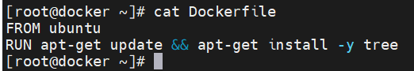

1. **Some more commands.**

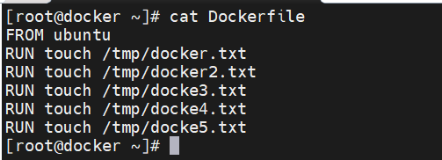

* **COPY will copy data as it is & ADD will untar your file and copy.**

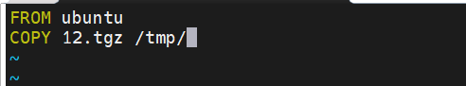

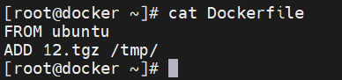

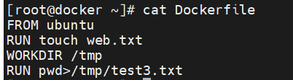

* **To go directly inside python instead of /bin/bash**

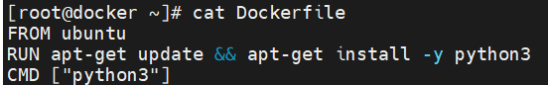

* **To expose the ports**

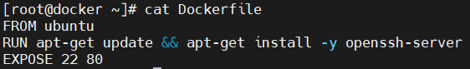



* **Entrypoint used to execute any script as per requirement while building the image itself.**

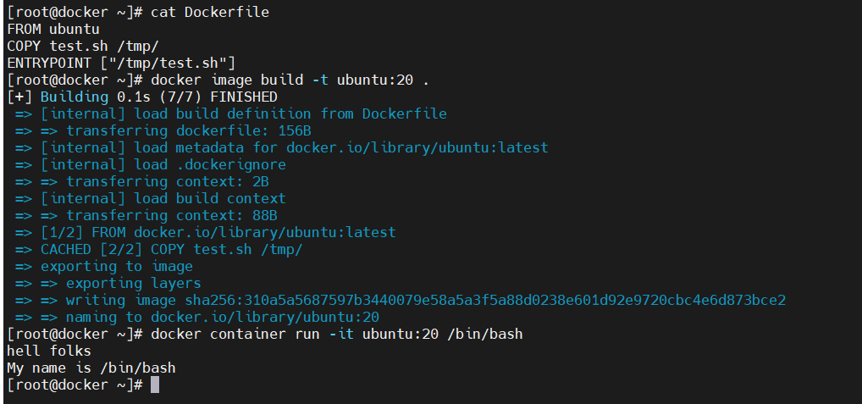

1. **Docker work on layers. e.g. For each command from docker-file, it will create separate container temporary and remove it after final command. Also, if you run same docker-file again then it will refer details from caching containers. So always add new command at last line in docker-file to save time.**